Don’t Rock The Boat
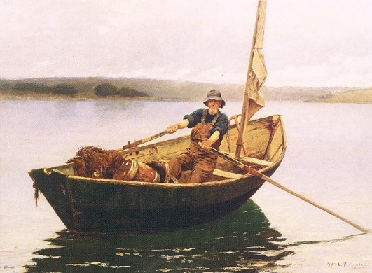
A man is transporting some rocks in a small boat in a small pond. He accidentally drops some rocks into the pond during transport and the rocks sink to the bottom.

You will be working in a group to design an experiment to answer the following question.

Question:
What will happen to the level of water in the pond when the rocks are dropped into the pond?

Prediction (Claim): Write a prediction and explain why you or your group are making this claim.
__________________________________________________________________________________________________________________________________________________________________________________________________________________________________________________________________________________________________________________________________________________________________________________________________________________________________________________________________________________________________________

Materials:

- Test tube
- Pebbles
- Beaker
- Graduated cylinder

Designing an experiment:
Using the equipment above, design an experiment to show what will happen to the water level in the pond as rocks are dropped from the boat. Use the space below to draw diagrams and step by step procedures for your experiment.

Data (Evidence): Create a data table to show what data you have collected from your experiment.

Conclusion (Reasoning): Write a paragraph that explains what happened in your experiment. Be sure to address the following questions
- Restate your claim.
- What evidence supports or refutes your claim. Explain how or why it supports your claim. If the evidence does not support your prediction/claim, explain what specific evidence does not support it.
- Were there any errors in your experiment? If so, what were they and how did they affect your experiment?

