Portfolio Assignment ___
The Endocrine System

Topic: The Endocrine System - Based on Chapter 35-3: Due Date_________________
Essential Information: Our brain communicates with the body via the nervous and endocrine systems. Otherwise the brain is basically sitting in the dark box which is the cranium of the skull. This communication is through electrical nerve impulses from the nervous system and the use of chemicals called hormones, from the endocrine system. Hormone levels are controlled by a negative feedback system, similar to your house thermostat. The body tissues which react to the hormones are called the target tissues.

- Read Chapter 35-3 in your Biology Text. For each of the “Vocabulary” terms in the chapter summary write the definition and give an example or diagram the concept which the word represents. (section 35-3 only for now)
Term | Definition | Example/Diagram/Analogy

- Copy and complete the following concept map.
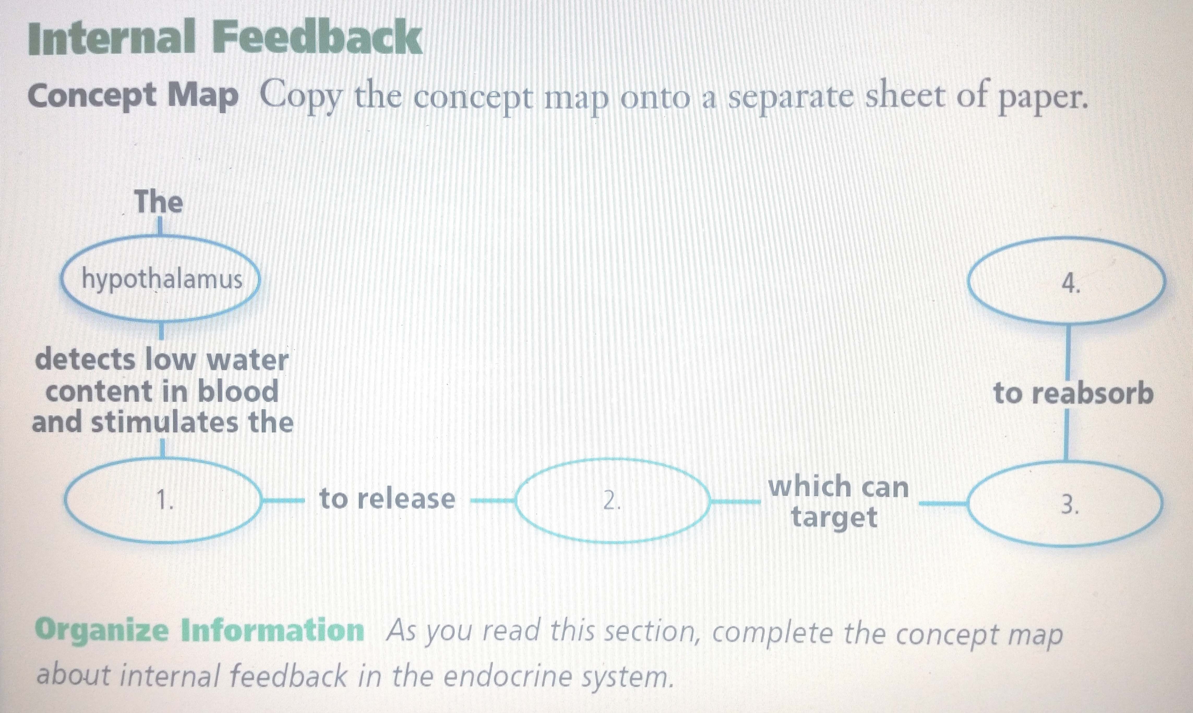

- Read chapter 35-3and change every one of the 13 RED and BLUE headings into a questions then answer the question in a two column Cornell style table
Questions | Answers
- How is the body controlled?
- How do the Nervous and Endocrine systems interact?

- Copy and label Figure 35.10 which is a diagram of the “Principal Human Endocrine Glands”. Include all of the diagram captions. Underneath the diagram write a paragraph titled “How the pituitary gland is like an orchestra conductor “in which you describe how the role of the pituitary is like that of a conductor, where all the other glands are like the orchestra musicians.

- Create a table titled Hormone Action, in which you compare Steroid Hormones to Amino Acid hormones.

Steroid Hormones | Amino Acid Hormones

- Complete Problem Solving Lab. 35-3 by answering the “Thinking Critically” questions.
- Answer the “Section Assessment’ questions for sections 35-3 .

