Portfolio #2
Ecology Science Project (Continued)

Topic 3: Limiting Factors, Tolerance and Succession (chapter 3-1): Due Date________________

- Watch the Ecology PowerPoint for Chapter 3-1. On a piece of paper titled “Chapter 3-1 Ecology Notes” define each of the terms colored in red. Following the presentation write down at least three examples, write an analogy or create a simple diagram for each term
Ecology Term | Definition | Example/Diagram/Analogy

- Read Chapter 3-1 in your Biology Text
- For each of the 6 “Vocabulary” words in the chapter 3-1 summary (pg. 87 in the blue text) write the definition and give an example or diagram the concept which the word represents, if you already defined the word from the Powerpoint then you do not have to do it again. Remember we are only covering Section 1 of chapter 3
- Copy and Label the diagram on “Limits of Tolerance” from Figure 3.2 on page 66 and also copy the diagram caption next to the diagram. Underneath the diagram write a paragraph, in your own words and based on your own thoughts, which describes: 1) How “Limiting Factors” can create ranges of tolerance; 2) Why there are no creatures without “Limits of Tolerance”; 3) Which creature or organism has the greatest limit s of tolerance (in your opinion) and why you picked that creature.
- On a blank piece of paper titled “Primary and Secondary Succession”, copy and label figure 3.3 from page 68 of your text. Underneath the diagram create a table where you compare and contrast Primary Succession to Secondary Succession. Have at least five entries for each type of succession. Explain how these types of succession are similar and different from each other.
Primary Succession | Secondary Succession
(List 5 things) | (List 5 things)

- Complete “Problem Solving Lab. 3-1” from page 68 by copying the graph and answering the “Thinking Critically” questions.
- Answer the “Section Assessment” for section 3-1 found on page 69 of your text.

Topic 4: Carrying Capacity, Density Dependent Factors, Exponential Growth and Demography (Chapter 4): Due Date_________________

1) Watch the Ecology PowerPoint for Chapter 4. On a piece of paper titled “Chapter 4 Ecology Notes” define each of the terms colored in red. Following the presentation write down at least three examples, write an analogy or create a simple diagram for each term
Ecology Term | Definition | Example/Diagram/Analogy

- Read Chapter 4 in your Biology Text
- For each of the “Vocabulary” words in the chapter summary (pg. 107 in the blue text) write the definition and give an example or diagram the concept which the word represents, if you already defined the word from the PowerPoint then you do not have to do it again.
- Create brochure where you describe the effects of Population Increase, Carrying Capacity, The Environment and Other Organisms on population size. See instructions below.
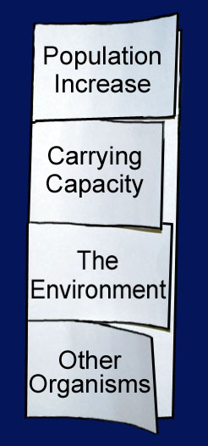
Fold a sheet of paper in halfhalf lengthwise.
Fold in half and half again make three folds.
Unfold and cut only the top
layer along the three folds to
make four tabs then label the tabs
5) Linear vs. Exponential Growth Assignment
Mr. Kardouche was offered this choice of two jobs. The first job pays $200 per day. The second job pays one cent on the first day and his salary is doubled every subsequent day. Draw a table showing how much money he would make at each job and make a line graph of the amount of money he would make for the month. Answer the following questions: 1) Which of these graphs is linear and which is exponential? How can you tell? 2) What is the shape of each type of graph? 3) Do living things (organisms) reproduce linearly or exponentially? Explain why. 4) What is the effect of carrying capacity on exponential growth for an organism? 5) Draw a graph of linear growth, exponential growth and exponential growth with carrying capacity. 6) Which of these graphs do animal experience and which graph type do humans experience? Explain why?

- Complete the Chapter Assessment questions for Chapter 4

- Complete the handouts titled Chapter 4 Study Guide.

- Complete the activity titled “ The Lessons of the Kaibab”

- Answer the questions from the handout titled “Limiting Factors and Carrying Capacity” while watching a video on that topic.

