Evolution Biology Project #3

Topic 3: Based on Chapter 15-1 – The Record of Life: Due Date______________

- Using your textbook as a reference, define the term “Evolution”. Underneath the definition, write down what that means, using your own words and examples. Refer to this definition as you complete the rest of the assignments. Many people have their own notions regarding what evolution means and it is helpful to keep this academic definition in mind as we wrap up this unit.
- Watch the Evolution PowerPoint for Chapter 15. On a piece of paper titled “Chapter 15 Theory of Evolution Notes” define each of the terms colored in red. Following the presentation write down at least one example, write an analogy, or create a simple diagram for each term
Evolution Term | Definition | Example/Diagram/Analogy
- For each of the “Vocabulary” terms in the chapter summary (pg. 389 in the blue text) write the definition and give an example or diagram the concept which the word represents, if you already defined the word from the PowerPoint then you do not have to do it again.
- As you read chapter 15-1, Summarize, analyze and critique the direct and indirect evidence used to support the theory of evolution in a foldable brochure as follows:
  A  Draw a mark at the midpoint of a vertical sheet of paper along the side edge. | 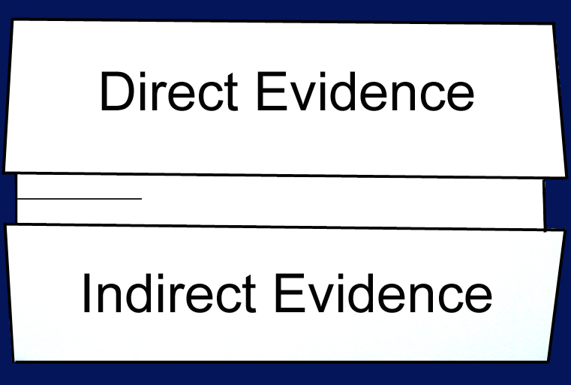  Turn the paper horizontally and fold the outside edges in to touch at the midpoint mark.
For direct evidence copy figure 15-5 along with the captions - On the other side of the flap give your opinion as to whether or not this evidence proves evolution and justify your reasoning. For indirect evidence include mimicry, camouflage, fossils, homologous structures, vestigial structures, embryology and biochemistry. For each of these explain how each supports the theory of evolution
- Pretend that you are Charles Darwin. Create an autobiography using diagrams within your autobiography to clarify and elaborate on your concepts. Read section15-1 and do some Internet research to complete the autobiography. Make it colorful. The following items need to be part of the autobiography: The HMS Beagle; The Galapagos islands; The Galapagos finches; The Galapagos turtles; an explanation of the Theory of Natural Selection (see figure 15-2). Include as many diagrams as possible.
- Complete Problem-Solving Lab. 15-1 regarding light and dark moth frequencies.

Topic 4: Based on Chapter 15-2 – Mechanisms of Evolution: Due Date______________

- Complete the peanut shell variations lab found in MiniLab-15-2 on page 407 of your text. Turn-in a complete lab report including the 9 steps found on the “How to Write a Laboratory Report Handout” which is on my web page and which you used for your first portfolio.

- Copy Figure 15.14 along with the diagram captions. Below the diagram, choose any animal which lives in the wild and predict the type of Natural Selection that the population of the animal you selected would be likely to follow. Explain the reasoning behind your prediction. You don’t have to be right; you just have to be logical in completing this part of the assignment.

- Copy Figure 15-18 which shows adaptive radiation in finches. Think of another population of animals that may have undergone adaptive radiation. Underneath the figure explain which other animal may have gone adaptive radiation and justify your answer. Again, you don’t have to be right; you just have to be logical.

- Complete the Chapter Assessment questions for Chapter 15.

Topic 5: List all the assignments given in class which were not part of this assignment sheet:

- _______________________________________________________________________________
- _______________________________________________________________________________
- _______________________________________________________________________________
- _______________________________________________________________________________

