Evolution Review Guide Answer Key

Things you need to know/ be able to answer:

- What were the typical ideas of the age of the earth & evolution before Darwin?
- Explain the theory of Natural Selection and the four ideas is it based on.
- Compare and contrast Darwin and Lamarck’s theories.
- Explain the meaning of evolutionary fitness.
- What is artificial selection and human’s role in it?
- How & why traits are passed on from generation to generation?
- Know how to analyze sedimentary rock strata and potential fossils/ common ancestry.
- It would be very convenient for penguins (birds) to have gills. Why haven’t they evolved them by natural selection yet?
- Genetic drift vs. Gene Flow
- How to analyze and create cladograms/ evolutionary trees 11. Hardy-Weinberg Equilibrium:
  - Understand the parts of the equation
  - How to answer problems with populations in HW
- Explain the significance of genetic mutations on evolution
- Why organisms can lose seemingly essential organs/ body structures (ex. Eyes)?
- Why doesn’t evolution lead to a population of identical individuals?
- Explain why there is no such thing as evolution towards perfection
- Drug resistance in bacteria and natural selection
- Sickle Cell Anemia & the heterozygote advantage
- Hybrid Zones/ Hybrids
- Types of reproductive isolation
- Stanley Miller’s hypothesis, experiment & conclusions
- RNA as the first hereditary material, & why scientists think this (3 characteristics).
- Types of Natural Selection (how to analyze graphs)
    - Directional
    - Stabilizing
    - Disruptive
- CLADOGRAMS & PHYLOGENETIC TREES

FRQ Topic Possibilities:
  - Darwin’s Theory of Evolution & how modern science have refined evolution
  - Evolutionary Biologists (Lyell, Lamarck, Darwin, Wallace, Miller,
  - HW Equilibrium (with Chi-Squared?)
  - Analyzing/ Creating Phylogenetic Tree based off data table
  - Evidence of Evolution
  - How Genetic Changes can happen and affects genetic variation

Types of Questions:

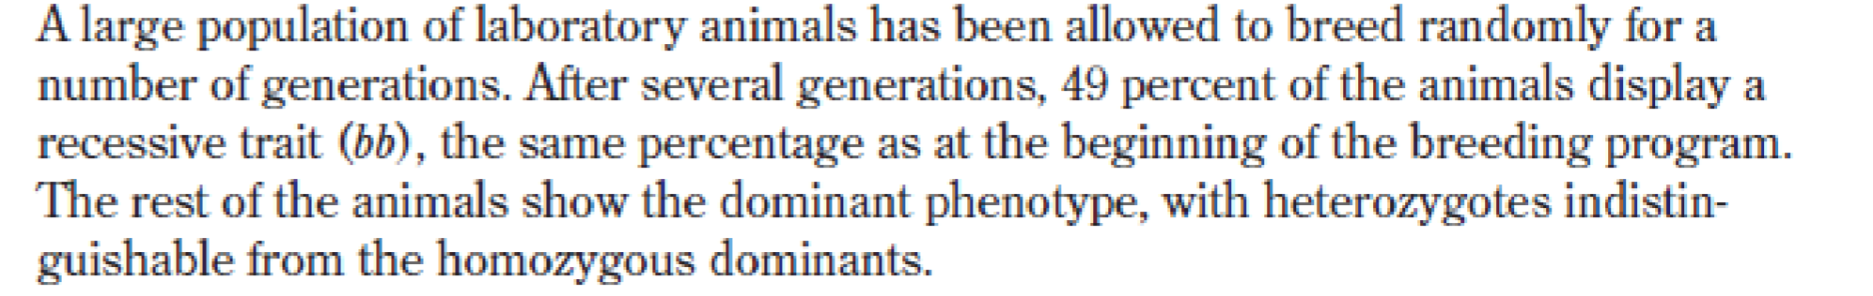
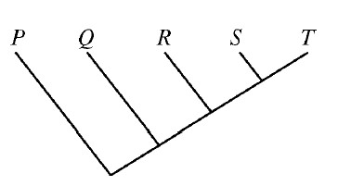
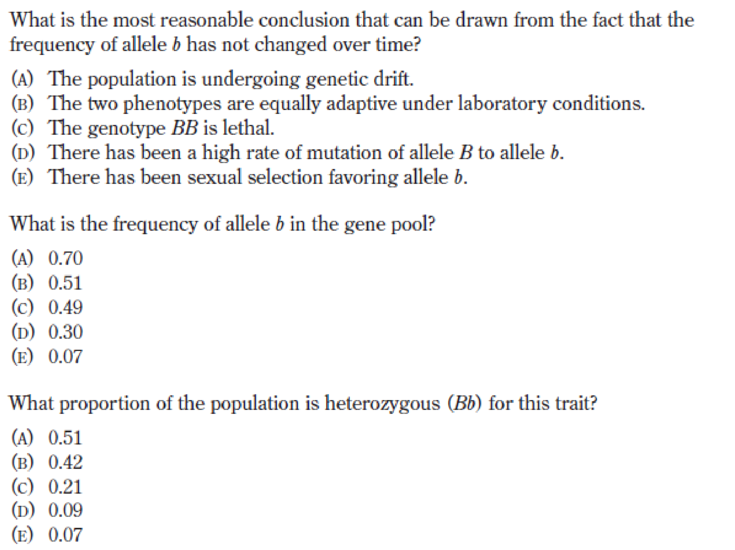
1)
4)

Which of the following conclusions is best supported by the cladogram on
the right?

(
A
)

Species P a
nd Q are equally related to species T.

(
)
B

Species P and T do not share a common ancestor.

(
C
)

Species S evolved from species R.

(
D
)

Species S is more closely related to species T than to species R.

2)

3)

- Cladograms (a type of phylogenetic tree) constructed from evidence from molecular data are based on similarities in
  - mutations to homologous genes
  - the pattern of embryological development
  - biochemical pathways
  - morphology

Species | 1 | 2 | 3 | 4
1 | - | 1 | 5 | 6
2 | 1 | - | 6 | 7
3 | 5 | 6 | - | 1
4 | 6 | 7 | 1 | -
Four new species of plants were discovered in
4
3 1
2

Greenland ice core samples. The nucleotide (base) sequences of rRNA subunits were determined for the new species. The table below shows the number of nucleotide differences between the species.
- Create a Cladogram for the data provided.

  - group of biologists is studying the effect of extreme weather conditions on a population of sparrows. The population of sparrows resides in the Midwest, which has experienced several thousand severe storms over the past decade. The biologists hypothesize that the increase in storm frequency and severity has an effect on the frequency of long and short-winged birds, since medium-sized wings allow the birds to survive these storms better. The biologists collect phenotype frequency data about the wing length trait in the sparrow population, shown below.

- Which of the statements below would be supported by the researchers’ data?
  - Sparrows with short wings will be directionally selected for in environments where severe storms are common.
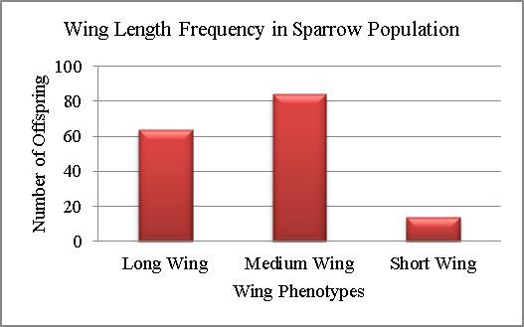
  - Stabilizing selection occurs in environments where severe storms are common, selecting for sparrows with medium-sized wings.
  - Disruptive selection selects for both sparrows with long and medium-sized wings in environments where severe storms are common.
  - The frequency and severity of storms has no effect on the sparrow wing phenotype frequency.

- The diagram on the right represents undisturbed rock strata in a given region. A representative fossil of an
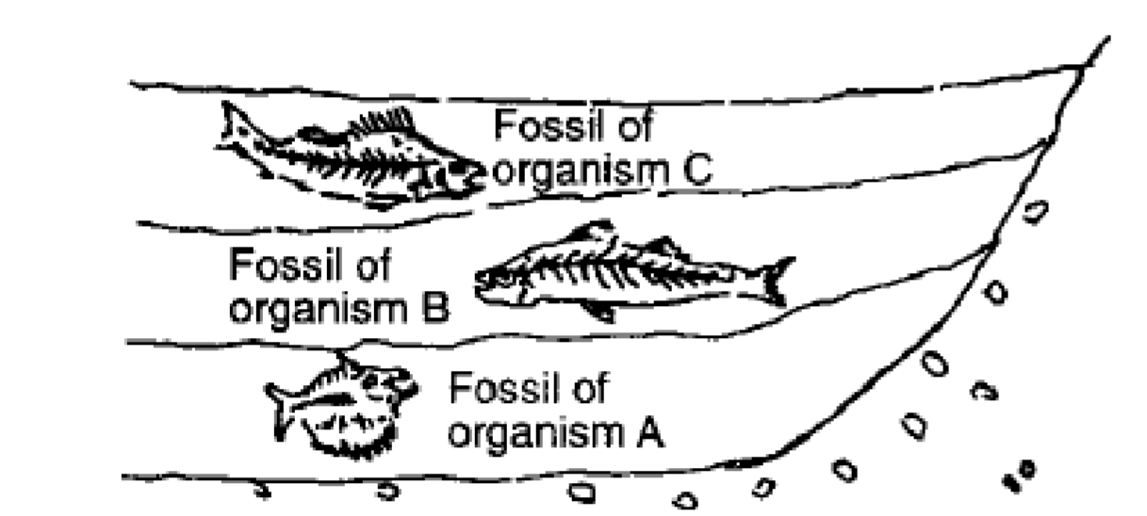
organism is illustrated in each layer. Which statement
best desc
ribes a relationship between these
representative organisms?

a.

Organism A was probably more structurally
advanced than organism B and organism C

b.

Organism C probably gave rise to organism A
and organism B

c.

All of these organism
s

probably evolved at the
same ti
me

d.

Organism A was probably more primitive than
organism B and organism C

- If two modern organisms are distantly related in an evolutionary sense, then one should expect that A) they should share fewer homologous structures than two more closely related organisms.
- their chromosomes should be very similar.
- they shared a common ancestor relatively recently.
- they should be members of the same genus.

- A population of squirrels is preyed on by small hawks. The smaller squirrels can escape into burrows. The larger squirrels can fight off the hawks. After several generations, the squirrels in the area tend to be very small or very large. What process is responsible for this outcome, and what would you predict would be its effect on allele frequencies?
  - Directional selection; the allele for small squirrel size is not favored over the allele for large squirrel size
  - Disruptive selection; the allele for large squirrel size is favored over the allele for small squirrel size
  - Stabilizing selection; the alleles for large and small squirrel size are found in equal frequency in the population
  - Disruptive selection; the alleles for large and small squirrel size are favored equally in the population

Trout in stream A and trout in stream B look similar, but not quite identical. Scientists were unsure if they were two populations of one fish species, or two separate species. To figure this out, they studied the life cycle, habitat, and reproduction of the trout. In a year with a typical amount of rainfall, the trout stay within their own stream and mate with individuals that live nearby. However, in years that include excessive rainfall and flooding, the fish are washed downstream to a larger river, and must swim back up into either stream A or stream B. They choose which stream to swim up randomly, often ending up in a different location than where they themselves were born. When a trout that originated from stream A does breed with a trout from stream B, their offspring are healthy and show no decrease in fertility. Scientists think that flooding in this watershed is happening more and more frequently, due to global climate change.
- Given this information, predict what is the most likely result for trout A and trout B. a. they will become reproductive isolated from each other
- they will become more similar in their gene pools
- they will go through random changes due to genetic drift
- they will adapt to different conditions and look more and more different

A group of students summarized information on five great extinction events.
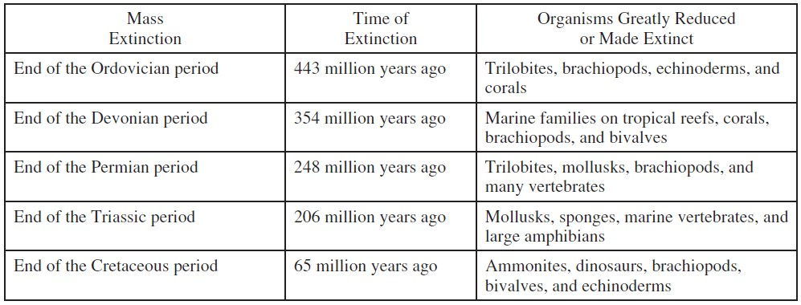
12) The students are sampling a site in search of fossils from the Devonian period. Based on the chart, which of the following would be the most reasonable plan for the students to follow? (A) Searching horizontal rock layers in any class of rock and try to find those that contain the greatest number of fossils
- Collecting fossils from rock layers deposited prior to the Permian period that contain some early vertebrate bones
- Looking in sedimentary layers next to bodies of water in order to find marine fossils of bivalves and trilobites
- Using relative dating techniques to determine the geological ages of the fossils found so they can calculate the rate of speciation of early organisms

